Assignment No 10

(1) Students table

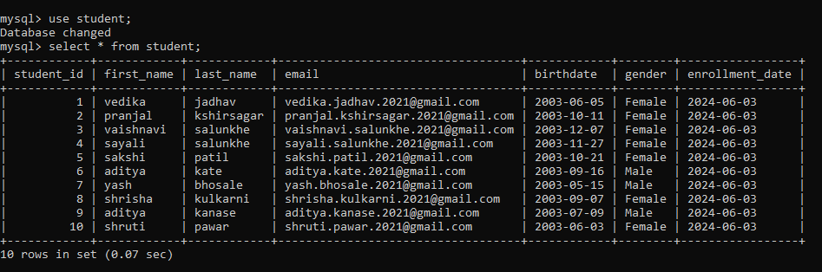

(2) courses table
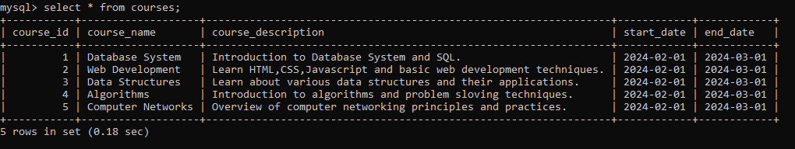

(3) Enrollments table
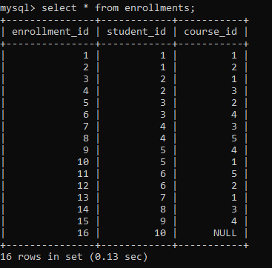

Question 1) Retrieve a list of all students along with the courses they are enrolled in, including students who are not enrolled in any course.

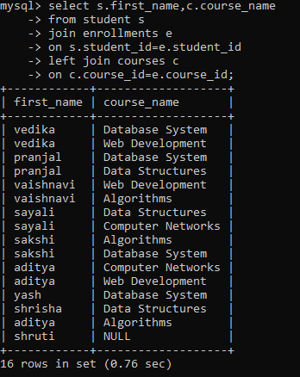
Question 2) Find the number of courses each student is enrolled in, and include students who are not enrolled in any course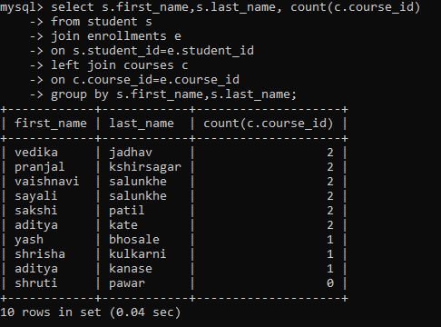
Question 3) List all courses along with the number of students enrolled in each course. Include courses that currently have no students enrolled.
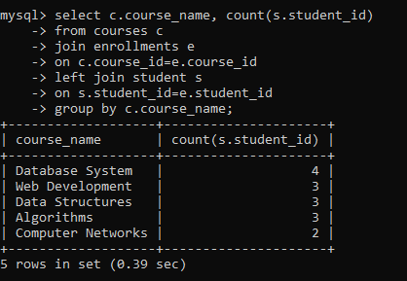

Question 4) Find the names of students who are enrolled in both 'Database Systems' and 'Web Development' courses.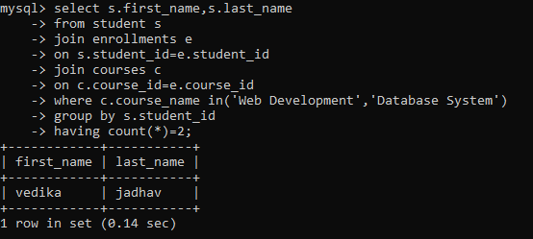Question 5) Retrieve the first name, last name, and email of students who are enrolled in exactly two
Courses.
